Assignment 4

# Display the list of products that are out of stock

--1

alter table product_supply add availability_status varchar(40);

update product_supply set availability_status='out of stock' where supplier_name='exotic liquids'

select prod_name from product_supply where availability_status='out of stock'

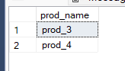

# Display the list of products whose unitinstock is less than unitonorder

--2

alter table Product add unitinstock int, unitonorder int;

update Product set unitinstock=12,unitonorder=24;

SELECT * FROM Product WHERE unitinstock<unitonorder;

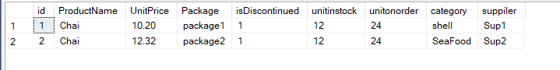

# Display list of categories and suppliers who supply products within those categories

--3

alter table Product add category varchar(20),suppiler varchar(20);

update Product set ProductName='Chai',category='shell' ,suppiler='Sup1' where id=1;

update Product set ProductName='Chai',category='SeaFood' ,suppiler='Sup2' where id=2;

insert into Product values (3,'abc',123.2,'pakage2',0,13,12,'shell','sup3');

select category ,suppiler from Product order by category;

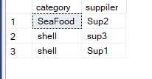

# Display complete list of customers, the OrderID and date of any orders they have made

--4

select c.id,c.FirstName,c.LastName,o.id as 'Order_id',o.OrderDate from Custermer as c left join Orders as o on c.id=o.Custermerid;

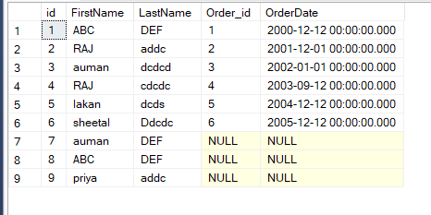

# Write query that determines the customer who has placed the maximum number of orders

--5

select * from Custermer where id in

(select Custermerid from Orders group by Custermerid having count(id)=

(select top 1 COUNT(id) from Orders group by Custermerid order by 1 desc)

);

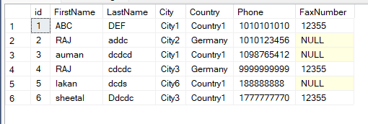

# Display the customerid whose name has substring ‘RA’

--6

update Custermer set FirstName='RAJ' where id in (2,4);

select id from Custermer where FirstName like '%RA%';

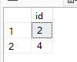

# Display the first word of all the company name

--7

insert into ShippingDetails values(124,'1233','2002-12-12',concat('La corned',char(39),'abondance'),1,'company name 1 ',3)

update ShippingDetails set Shipping_Comapany='FirstName Comapany' where ship_id in (121,122,123);

select substring(Shipping_Comapany,1,charindex(' ',Shipping_Comapany)) as 'NAME' from ShippingDetails;

